# MAEG 5720 Computer Vision in Practice

# HW3

XIA, Lei 1155169110

Dr. Terry Chang

November 12, 2021

## Question 1

### (c)

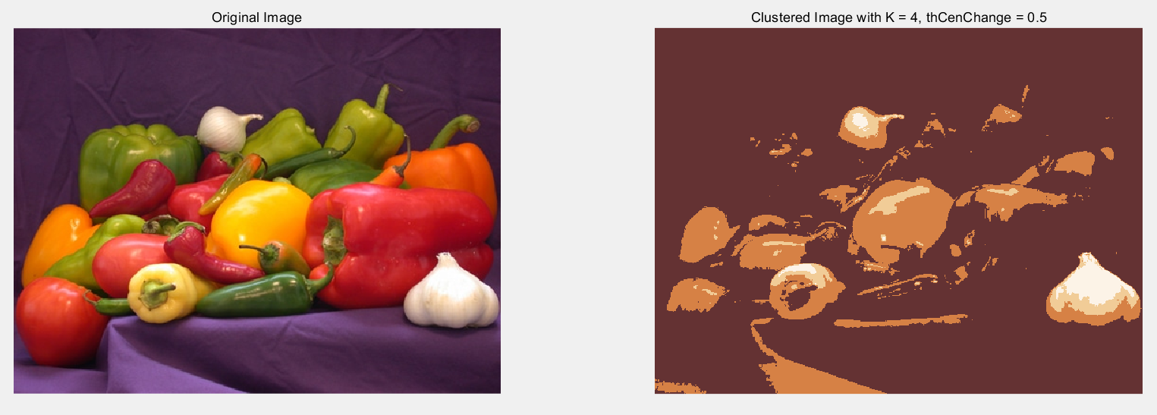

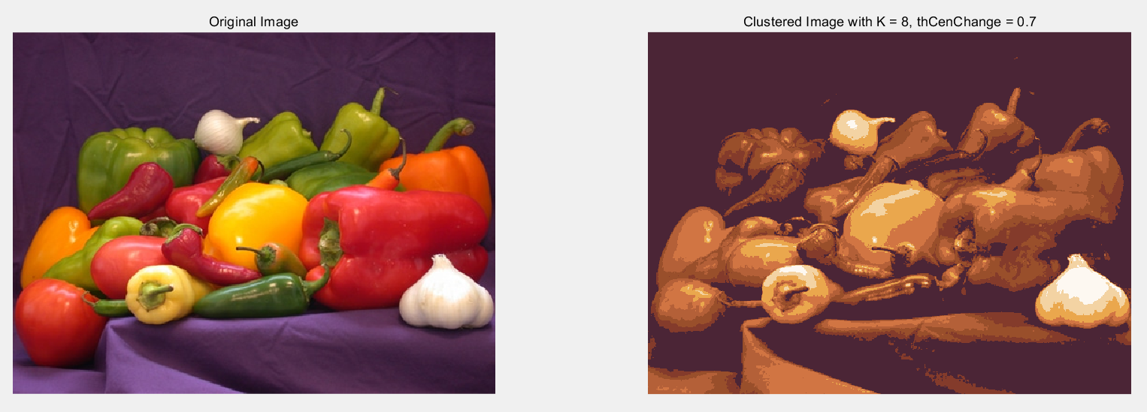

## Question 2

